DOI: xxx
Type: xxx

Design and Implementation of Quantum Repeaters: Insights into Quantum Entanglement Purification

Karoki A. Mũgambi* and Geoffrey O. Okeng’o
The Astrophysics and Space Science Research Group, Department of Physics, Faculty of Science and Technology, University of Nairobi, P.O. Box 30197–00100, Nairobi, Kenya.
*Corresponding Author: Karoki A. Mũgambi. Email: karokianthony.tphy@gmail.com
Received: XX Month 202X; Accepted: XX Month 202X
Abstract: Quantum communication is a groundbreaking technology that is driving the future of information transmission and communication technologies to a new paradigm. It relies on quantum entanglement to facilitate the transmission of quantum states between parties. Quantum repeaters are crucial for facilitating long-distance transmission. They extend the transmission range by fragmenting the channel into multiple small segments where they perform entanglement swapping between each segment endpoint until the sender and receiver become entangled, forming a complete quantum link for communication. This study focuses on quantum entanglement purification, a protocol aimed at maintaining high-fidelity entangled states above the operational threshold of the communication channel. This study investigates the optimal stage for executing the purification protocol and applies optimisation schemes to evaluate various purification protocols. We use IBM Qiskit for circuit implementation and simulation. The results offer valuable insights into future approaches to implement practical quantum repeaters and shed light on existing and anticipated challenges.
Keywords: Quantum repeaters; quantum entanglement; entanglement purification; quantum communication; entanglement swapping
1 Introduction
Quantum communication leverages the principles of quantum mechanics to transmit quantum information between remote locations. The quantum information is encoded in a qubit, which is the basic unit of quantum information. At the core of quantum communication is the principle of quantum entanglement, which gives rise to the phenomena of quantum teleportation as a new paradigm protocol for communication [1].
Currently, active experimental work in quantum communication channels is conducted either in optical fibres or free space, both of which are affected by noise during transmission. The photon intensity is attenuated exponentially with the transmission distance [2], [3]. This limits long-distance communication channels. Quantum repeaters were introduced to overcome this long-distance limitation [4].
Quantum repeaters are devices that extend the range of quantum channels. They do so by fragmenting communication channels into small segments composed of nodes or relay stations, each with a quantum repeater that teleports entangled states between adjacent nodes. We note that the terms nodes, relay stations, and stations are used interchangeably here and imply the same thing unless otherwise stated. The length of the segments is chosen such that it is less than the attenuation length of the channel [5]. Entanglement is established between adjacent nodes using the quantum entanglement switching protocol, eventually forming a large-scale quantum link from the sender to the receiver station [2], [6].
The main components of a quantum repeater include; quantum entanglement switching for swapping entangled states between adjacent nodes, quantum memory for storing quantum states for efficient on-demand retrieval, and quantum entanglement purification for enhancing the fidelity of the entangled states. These components have a few limitations arising from imperfections in the source of entangled particles, quantum operations and the interconnecting communication channels [7].
Despite these limitations, quantum repeaters have been successfully demonstrated in experiments, such as Herbst et al., who managed to use a quantum repeater to teleport an entangled state, a photon, between the Canary Islands of La Palma and Tenerife, approximately 143 km [7]. The entanglement swapping experiment used two polarization-entangled photon pairs generated in two identical spontaneous parametric down-conversion (SPDC) sources using a non-linear crystal, β-barium borate (BBO) [7].
The quantum entanglement purification protocol is a key component in quantum repeaters and is necessary for first-generation or near-term quantum repeaters [8]. It is essential to ensure that entangled states maintain high fidelity throughout the transmission [9], thereby compensating for loss of fidelity due to noise or imperfections in the communication channel. The two purification protocols employed in this research areBennett’s protocol [9] and Deutsch’s protocol [10]. Performance aspects considered for the purification protocols arethe fidelity of the purified Bell pair, success probability, and circuit length [11]. All protocols work towards obtaining shorter circuits that achieve higher success rates and improved final fidelity [11].
Quantum repeaters are necessary for future quantum communication technologies such as the quantum internet [4], [6]. They will extend the range of transmission links to an intercontinental global scale, powering the future of a global quantum network. A notable endeavour in this regard involves efforts to deploy quantum repeaters in existing optical fibre infrastructure [12]. However, their practical implementation in the real world is a huge technological challenge. There is much ongoing research investigating the individual components and full-scale architecture of quantum repeater systems.
This study presents the full-scale architecture of a quantum repeater designed and implemented using quantum circuits executed on a quantum computer. We used the proposed quantum repeater implementation to study quantum entanglement purification.
2 Experimental setup
2.1 Research Approach
This study presents a theoretical and computational approach. The architectural design of the quantum repeater is modelled on the basis of the use of quantum optics as opposed to earth to satellite links [13]. The conceptual implementation is, however, the same.
This study uses quantum backends made available by IBM Quantum. The coding was done using IBM Qiskit Python library. The backends represent either a native simulator, such as IBM’s Qiskit’s QASM simulator, or a real quantum computer. The environment exposed to superconducting qubits in IBM quantum computers can ideally emulate the same environment to which quantum repeaters will be exposed in real-world operation [5]. Each execution stage and protocol of the quantum repeater were translated into a modular quantum circuit that was independently executed on IBM Qiskit. The modularity of the code helped test different purification strategies, protocols, and components of the quantum repeater for better analysis. The quantum circuits were first executed on the native simulation backend, in which we incorporated a noise model that emulated IBM’s real quantum computers. Subsequently, the circuits were executed on physical IBM quantum computers, scheduling their execution to the backend with the least bus available. The findings reported here stem from the implementation on real quantum hardware. Performance analysis was performed based on the fidelity of the purified Bell pair. Optimisation schemes were applied to the entanglement purification circuits to analyse their performance.
2.2 Entanglement generation
The circuit implementation that prepares and generates an entangled pair takes two qubits as input and performs Hadamard and controlled-NOT (CNOT) unitary gate operations on them. Each Einstein–Podolsky–Rosen (EPR) pair is distributed to adjacent nodes. For instance, one pair, $${\left|Φ^{+}\right\rangle }_{AB}$$ gets to entangle A and B, while the other pair, $${\left|Φ^{+}\right\rangle }_{CD}$$ gets to entangle C and D.
2.3 Quantum Entanglement Distribution
The first distribution is that of the EPR pairs $${\left|Φ^{+}\right\rangle }_{AB}$$ and $${\left|Φ^{+}\right\rangle }_{CD}$$ to their respective nodes, with each node taking a qubit from a pair. The distribution stage that involves the quantum repeater requires the distribution of entanglement along the transmission line from the sender to the receiver. This entanglement distribution relies on quantum memories, entanglement purification protocols, and entanglement swapping protocols to distribute entanglement between nodes from the start of the communication link to the end.
2.4 Quantum memory
The entangled state $${\left|Φ^{+}\right\rangle }_{AB}$$ is momentarily stored in quantum memory, only to be retrieved when required for the entanglement distribution between nodes B and C, yielding the entangled state $${\left|Φ^{+}\right\rangle }_{BC}$$. Our circuit implementation emulates quantum memory by employing SWAP gates. It is imperative to note that our present formulation does not explicitly address the introduction of decoherence errors by quantum memory.
Achieving long coherence times limits the practical implementation of quantum memory [14]. An effective quantum memory device must demonstrate the capability to ensure extended storage periods with high efficiencies [15]. This attribute holds particular significance in the preservation of quantum properties, notably entanglement. SWAP gates are used in the circuit implementation to emulate quantum memory. The importance of quantum memory in the actualisation of quantum repeaters has driven the exploration of diverse technologies, notably those leveraging photonic channels [16] that use optical fibres [17], those employing diamond nanophotonic structures such as silicon-vacancy centres within diamond nanophotonic cavities [18] and those that use nuclear spins associated with nitrogen-vacancy centres [19]. We emphasise that this studydeliberately omits detailed discussions on the implementations of quantum memory.
2.5 Quantum Entanglement Purification
We constrained this research to two common purification protocols: Bennett’s protocol [9] and Deutsch’s protocol [10]. Each protocol has its own complexity of implementation. They also provide varying fidelity levels and produce varying degrees of overhead during circuit operation. Deutsch’s protocol is an enhancement over Bennett’s, introducing refinements to the purification process. Successful purification using these protocols yields coinciding measurement results as $$\left|00\right\rangle$$ or $$\left|11\right\rangle$$. Any other measurement result, either $$\left|01\right\rangle$$ or $$\left|10\right\rangle$$, indicates a failed purification operation, upon which the purification protocol needs a fresh restart. Fig. 1 and Figure Figure 2 shows the implementation of the two purification protocols. The implementation establishes three nodes: Alice, Charlie, and Bob as the communicating parties. Each node initiates the protocol by generating their respective Bell pairs. Both protocols leverage CNOT operations, using the qubits of one pair as control qubits and those of the other as target qubits.

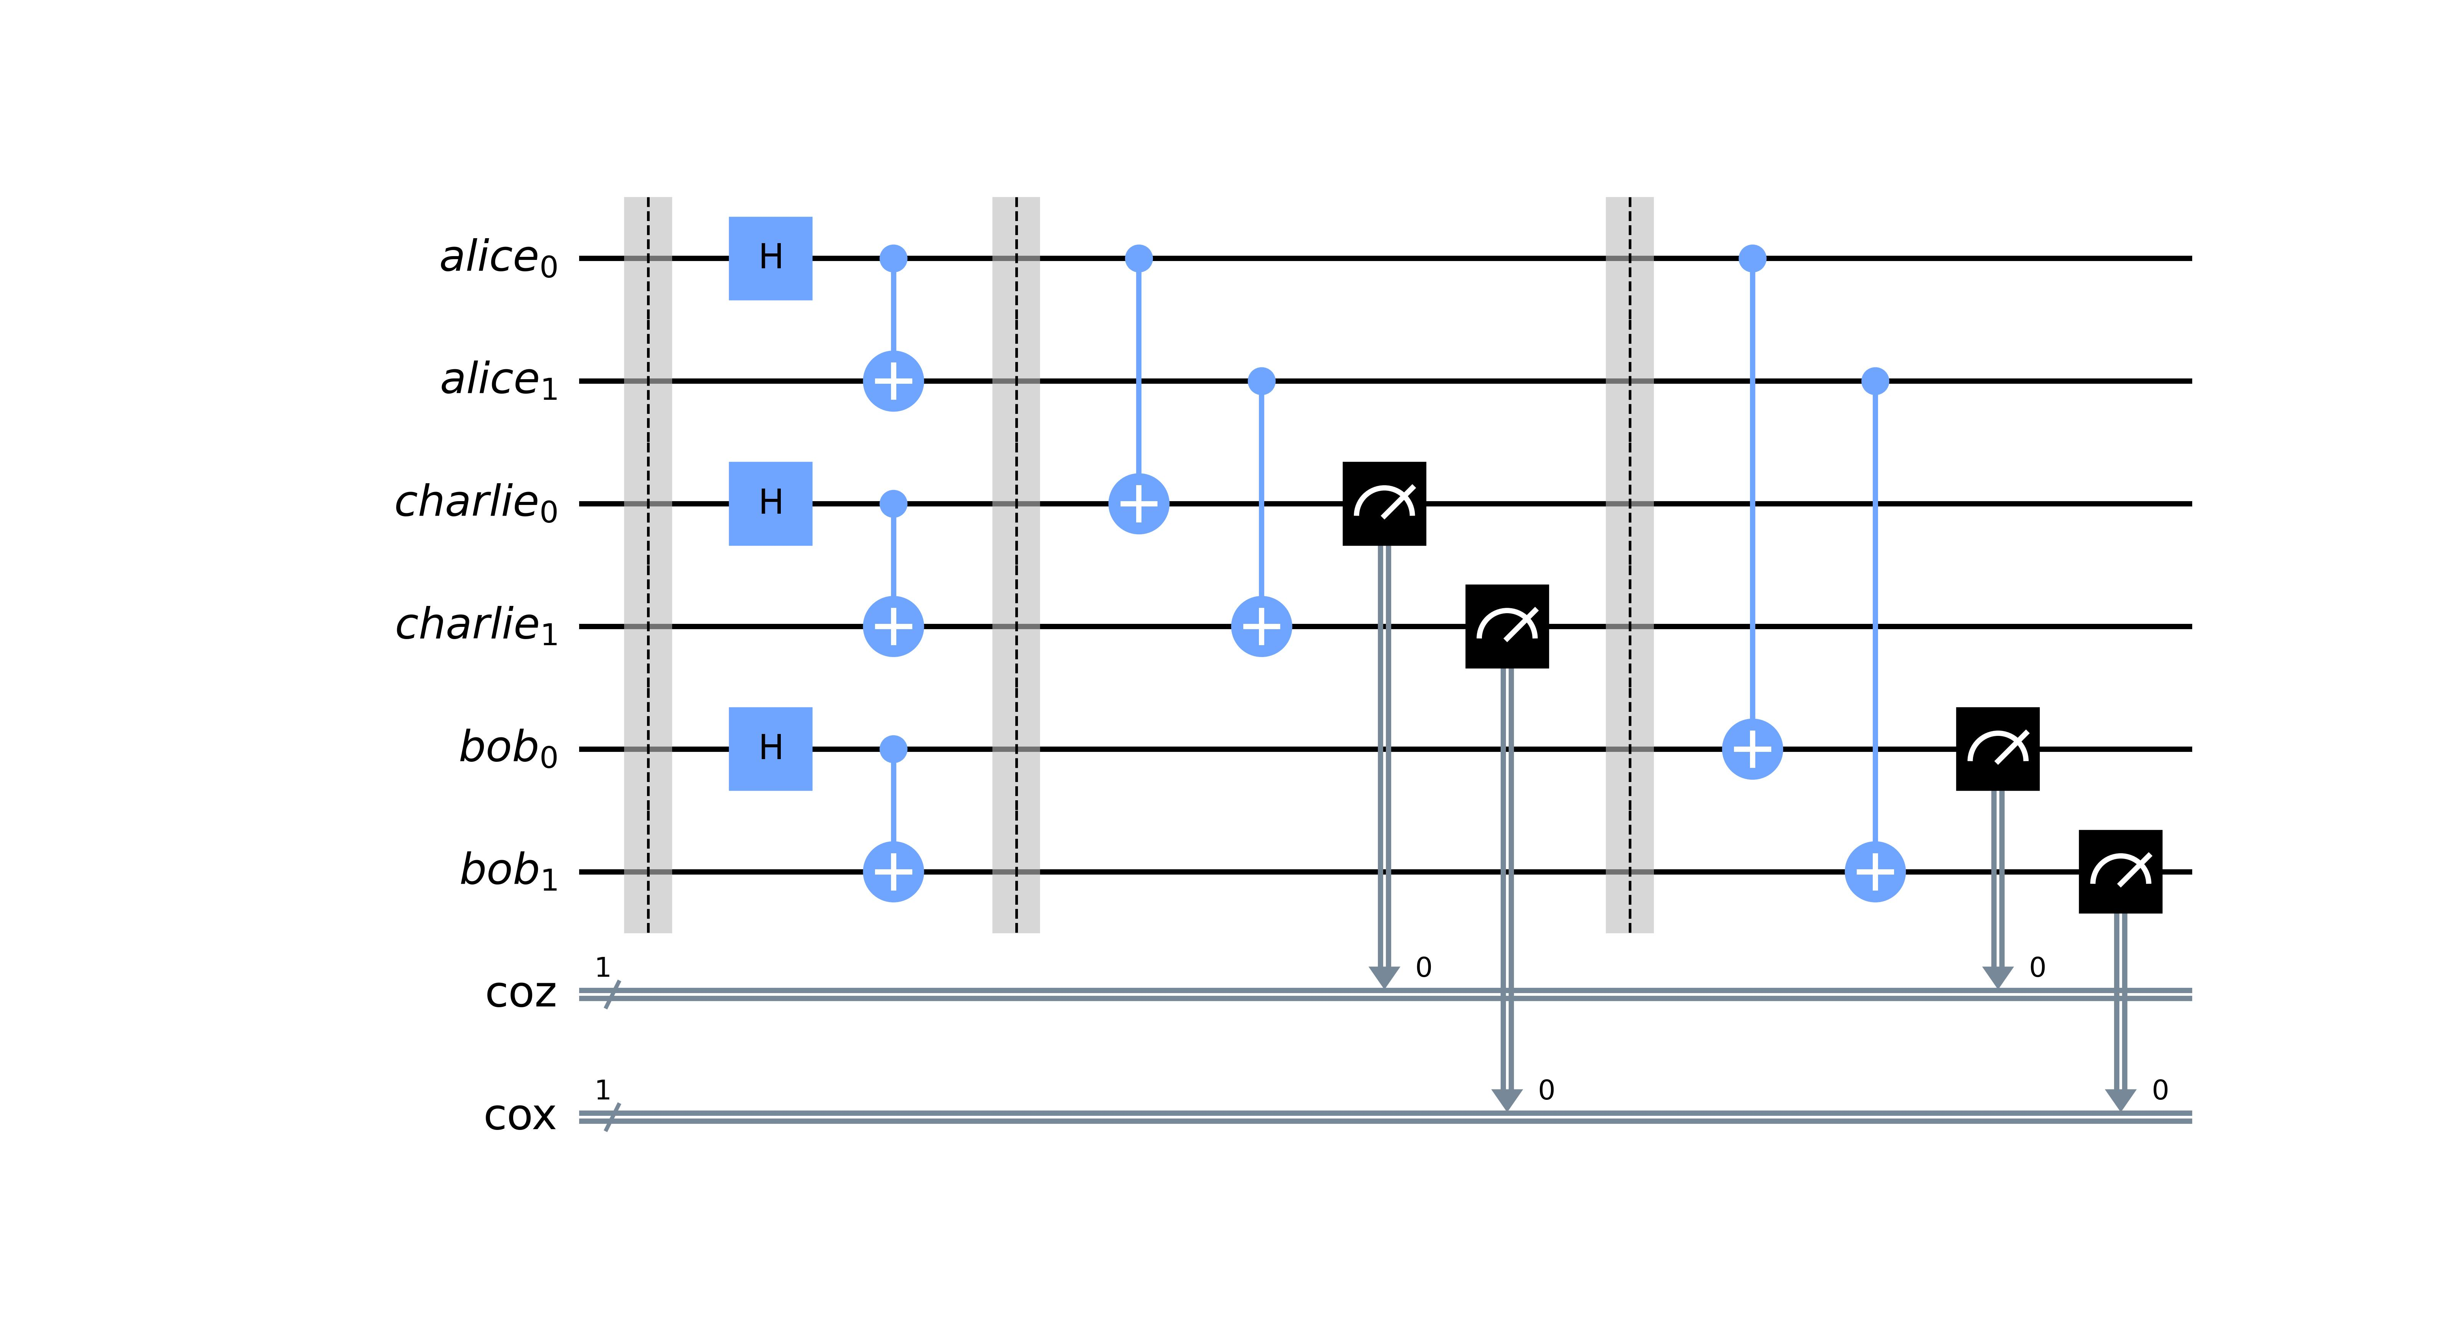
Figure 1: Quantum circuit implementation of Bennett’s purification protocol. This involves CNOT operations between the EPR pairs of each node. Alice’s pair acts as the control qubits, whereas Charlie’s and Bob’s pairs act as target qubits. Following CNOT operations between Alice and Bob, the target qubits undergo measurement. Coinciding measurement outcomes indicate successful purification, permitting the control qubits to advance to the next round with the subsequent node. Conversely, disparate measurement outcomes necessitate the termination of the purification attempt, which requires the discarding of all qubit pairs and a fresh restart. The subsequent round involves CNOT operations between Alice and Bob, with Bob’s qubits serving as the target, followed by measurements to assess the success of the purification process.
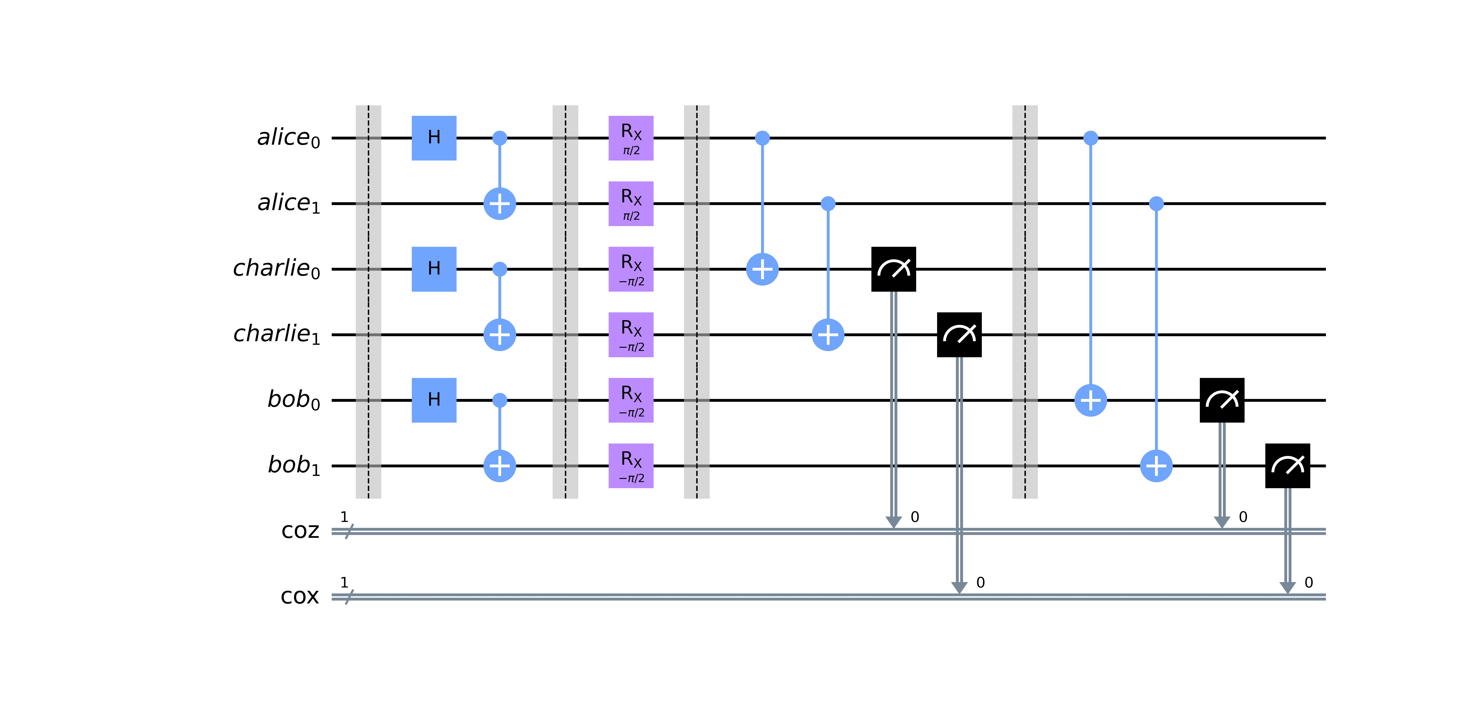
Figure 2: Quantum circuit implementation of the Deutsch purification protocol. It follows the same procedure as Bennett’s protocol, but with a slight modification by introducing single-qubit rotation operations before performing CNOT operations. The node with the control qubits, Alice, performs a $$R_{x}\left(\frac{π}{2}\right)$$ operation on all qubits, whereas every other corresponding node performs the inverse $$R_{x}\left(−\frac{π}{2}\right)$$ operation on all their qubits. The rotation operations correspond to rotations by $$\frac{π}{2}$$ and $$−\frac{π}{2}$$ about the x-axis. Thereafter, CNOT operations proceed as in Bennett’s procedure.
2.6 Quantum Entanglement Swapping
The quantum entanglement swapping circuit has a construction approach similar to that of the teleportation protocol [20]. Here, we demonstrate the teleportation of an entangled qubit by entangling one qubit of Alice’s Bell pair with another of Bob’s Bell pair. This is significant because it allows states previously not entangled and which had never interacted with each other before to become entangled with each other. This is the guiding principle for extending the length of a quantum link.
The elementary construction of the entanglement swapping circuit contains two Bell pairs collectively constituting a four-qubit quantum state $${\left|ψ\right\rangle }_{ABCD}={\left|Φ^{+}\right\rangle }_{AB}⊗{\left|Φ^{+}\right\rangle }_{CD}$$. Bell-state measurement (BSM) is performed between the qubits in B and C. Based on the measurement outcomes, an appropriate Pauli correction operation I, Z, X, and Y is performed on the qubit in D [5]. This results in the projection of qubits in A and D into the state $${\left|Φ^{+}\right\rangle }_{AD}$$ while simultaneously establishing entanglement between nodes B and C in the state $${\left|Φ^{+}\right\rangle }_{BC}$$. The achieved entanglement distribution from A to D maintains a quantum communication link that enables direct teleportation from node A to D. Notably, this study employs the conventional construction of entanglement swapping that requires CNOT gates. However, an alternative approach has been proposed that eliminates the need for CNOT gates, leveraging the quantum Zeno effect, which has the potential to reduce the quantum repeater circuit complexity and potentially improve the fidelity of quantum states [21].
The circuit in Figure 3 was executed in the backend, and measurements were performed in the computational bases, yielding the verification results in Figure 4 that show how successful the entanglement swapping was. The outcome of $$\left|00\right\rangle$$ for Alice’s and Bob’s qubits, $$alice_{0}$$ and $$bob_{1}$$ respectively, indicates successful entanglement swapping. Observe that this occurs on average roughly half the time in our case.

Figure 3: Quantum circuit implementation of the quantum entanglement swapping protocol. The quantum state to be teleported to Bob is Alice’s $$\left|alice_{0}\right\rangle$$. To verify the success of the protocol, a random two-dimensional quantum state vector is used to create an initialisation instruction labelled init instruction, which is applied to Alice’s qubits transforming $$alice_{0}$$ from $$\left|0\right\rangle$$ to some random state $$\left|ψ\right\rangle$$. Thereafter, EPR pair generation occurs. Entanglement swapping is performed, establishing entanglement between $$\left|alice_{0}\right\rangle$$and $$\left|bob_{1}\right\rangle$$ qubits while the rest of the qubits are discarded post-measurement. To validate successful entanglement, an inverse initialisation instruction labelled disentangler is applied to the entangled state $$\left|alice_{0}bob_{1}\right\rangle$$ on $$\left|alice_{0}\right\rangle$$ which should transform the teleported qubit from $$\left|ψ\right\rangle$$ to $$\left|0\right\rangle$$, yielding an expected measurement outcome of $$\left|00\right\rangle$$.

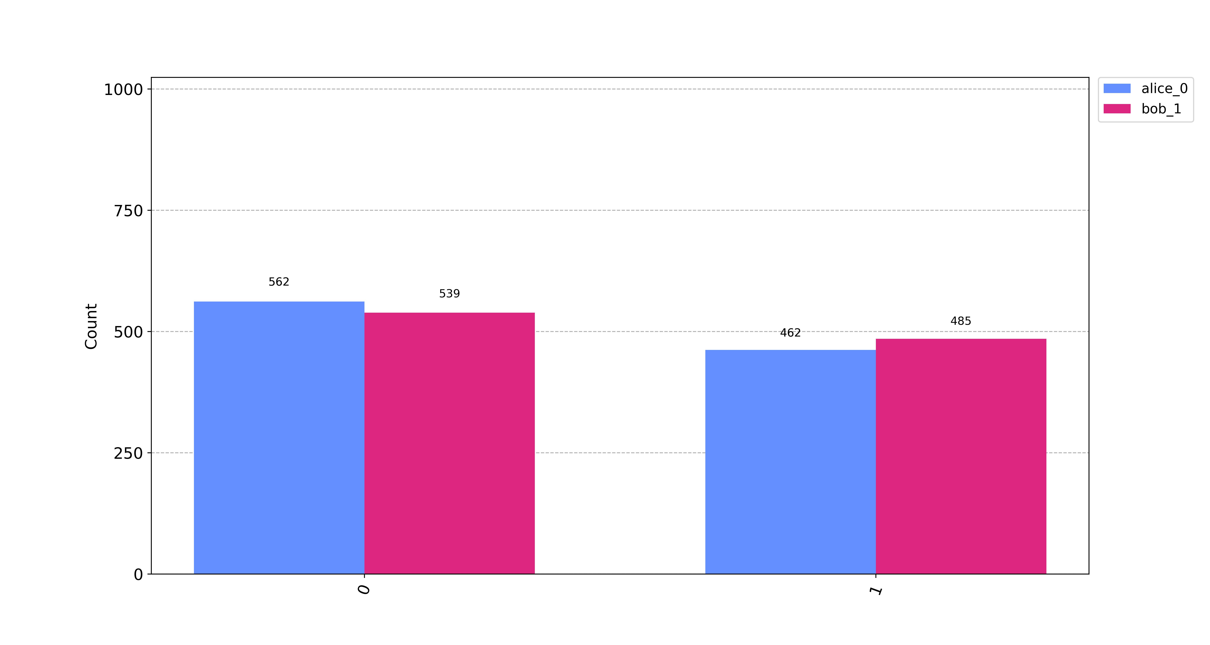
Figure 4: Results of verification of quantum entanglement swapping. Observe that for states $$\left|alice_{0}\right\rangle$$ and $$\left|bob_{1}\right\rangle$$, their measurement outcomes are measured to be in the $$\left|0\right\rangle$$ state roughly half the time. This indicates a successful swapping protocol on roughly half the executions.
3 Results and Discussion
3.1 Complete Quantum Repeater Architecture
Combining all the necessary components, we arrive at a complete implementation of a quantum repeater and its augmenting components in a quantum network [22]. The circuit architecture is shown in Fig. 5 and Fig. 6.
Figure 5: Quantum circuit for the complete quantum repeater, implementing Deutsch’s purification protocol just before the swapping protocol stage. qgen_alice and qgen_bob represent the modules generating Alice’s and Bob’s entangled qubits,, respectively. qmem represents the quantum memory devices present in a quantum repeater. The transmission of qubits through classical channels to either quantum channel of quantum memory is emulated using SWAP gates.
Figure 6: Quantum circuit for the complete quantum repeater, implementing Bennett’s purification protocol just before the swapping protocol stage.
Alice’s and Bob’s Bell pairs are first generated. One qubit from each Bell pair is transmitted to Alice and Bob through a classical channel. The remaining qubits from each Bell pair are transmitted through a classical channel to quantum memory devices found on the quantum repeater. The transmission of these qubits is emulated using SWAP gates. Through heralding [8], [23], a classical signal is sent to the repeater indicating that Alice’s and Bob’s qubits in memory are ready for swapping [24]. Heralding helps to synchronise the swapping protocol. The qubits in the quantum memory devices are transmitted to their respective quantum channels, ready for swapping. This transmission is again represented by SWAP gates. As illustrated in Fig. 5, Deutsch’s purification protocol is executed just before entanglement swapping. Finally, Alice’s and Bob’s qubits undergo Bell-state measurement. The presented circuit architecture provides a real-world implementation of the quantum repeater protocol. We used this to investigate our remaining objectives regarding purification strategies and optimisation schemes.
3.2 Purification Strategy
Identifying an optimum purification strategy for near-term quantum repeaters means better operation efficiency for future practical quantum repeaters. This is testament to approaches such as the nested purification strategy, which has been experimentally demonstrated to effectively minimise unwanted noise during entanglement swapping, yielding high-fidelity entangled states [25], [26].
In this study, three purification strategies were explored in the simulations. The strategies differ in the application stage of the purification protocol. These strategies areas follows: (1) post swap, purification after each entanglement swapping protocol; (2) repeated post swap, successive iterative purification instances after each entanglement swapping protocol (with three instances in our simulations); and (3) pre-and-post swap, alternating purification before and after an entanglement swapping protocol.
The simulations were exclusively conducted using Deutsch’s purification protocol, under the assumption that the outcomes would exhibit similarity across various purification protocols. This allows for variation of only the purification stage while keeping other aspects constant.
To conduct the purification strategy simulations, the compact form of the circuit shown in Fig. 5 was used. An initializer instruction was appended at the beginning of the circuit to perform a reset on Alice’s qubit, setting it into the state $$\left|0\right\rangle$$ then applying gates to turn it into a random state $$\left|ψ\right\rangle$$. After the start instruction followed the quantum repeater protocol, an inverse start instruction was appended. The inverse start instruction works to revert the random state $$\left|ψ\right\rangle$$ back to the state $$\left|0\right\rangle$$. Thus, upon measurement of Alice’s and Bob’s qubits at the end, ideally, one should obtain the state $$\left|00\right\rangle$$. The circuit was run 20 times, generating 20 independent measurement results each with its own set of probabilities for states $$\left|00\right\rangle$$, $$\left|01\right\rangle$$, $$\left|10\right\rangle$$ and $$\left|11\right\rangle$$. The results for all four quantum states across all 20 independent circuit runs were then averaged. The estimate of the true probability converges to the true probability as we increase the number of circuit runs. In this study, 20 runs gave us sufficiently good results in a reasonable simulation run time.
The results obtained were then used to verify that one qubit from Alice’s entangled qubit pair had been teleported to Bob. Measurements on either qubit can only yield state $$\left|0\right\rangle$$ or $$\left|1\right\rangle$$. The resulting plot is illustrated in Fig. 7. Ideally, we would expect 100% probability f for measuring Bob’s qubit in the state $$\left|0\right\rangle$$. Higher estimated probabilities indicate an increased likelihood of successful execution of the quantum repeater protocol, as theoretically expected. As observed, this occurs approximately half the time. This is expected because the processes of entanglement swapping and entanglement purification are inherently probabilistic.
These compelling results substantiate the efficacy of the purification strategies employed in achieving the teleportation of quantum information between distant nodes. The close alignment of the observed outcomes with theoretical predictions and prior literature [5] lends robust support to the accuracy and reliability of the quantum repeater protocol strategies under investigation.
Fig. 8 shows the results of the impact purification had on the fidelity at different stages in the quantum repeater protocol. The considered stages are the initial distribution stage (dist), the first swapping stage (aswap1), the second swapping stage (aswap2), and eventually the end of the node. Fidelity measurements were obtained at each stage by duplicating the quantum circuit up to the specific stage, executing the circuit, and performing the measurements. This was repeated across the 20 simulation runs, resulting in 20 independent measurement sets, each containing four measurements corresponding to the four considered stages. The results were averaged before performing the Hellinger fidelity operation to obtain the fidelity between consecutive stages.
Evidently, initial entanglement distribution has no effect on fidelity. However, realistically, fidelity loss occurs at this juncture and is primarily influenced by the technology used in entanglement generation — especially when employing a parametric-down-conversion source [23] — and the characteristics of the distribution channel. This crucial aspect was not accounted for in the simulation, leading to the observed results. Heralded entanglement generation is the most practical method for suppressing errors at this stage [8]. The fidelity of the Bell pairs suffers during entanglement swapping.
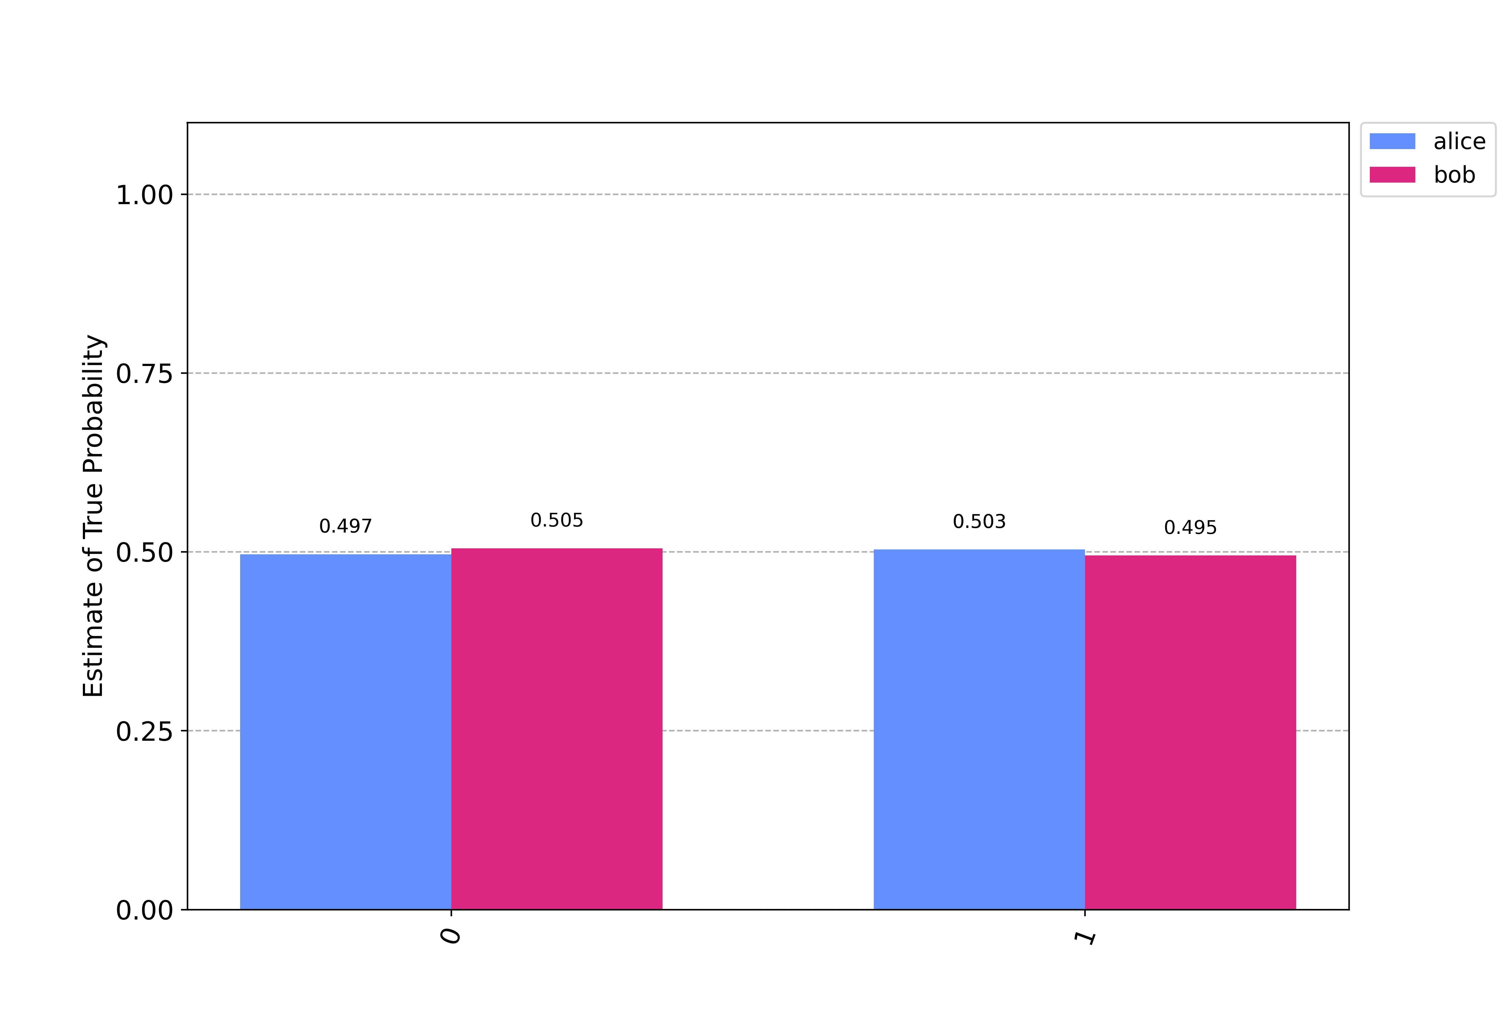  (a) Post swap purification strategy | 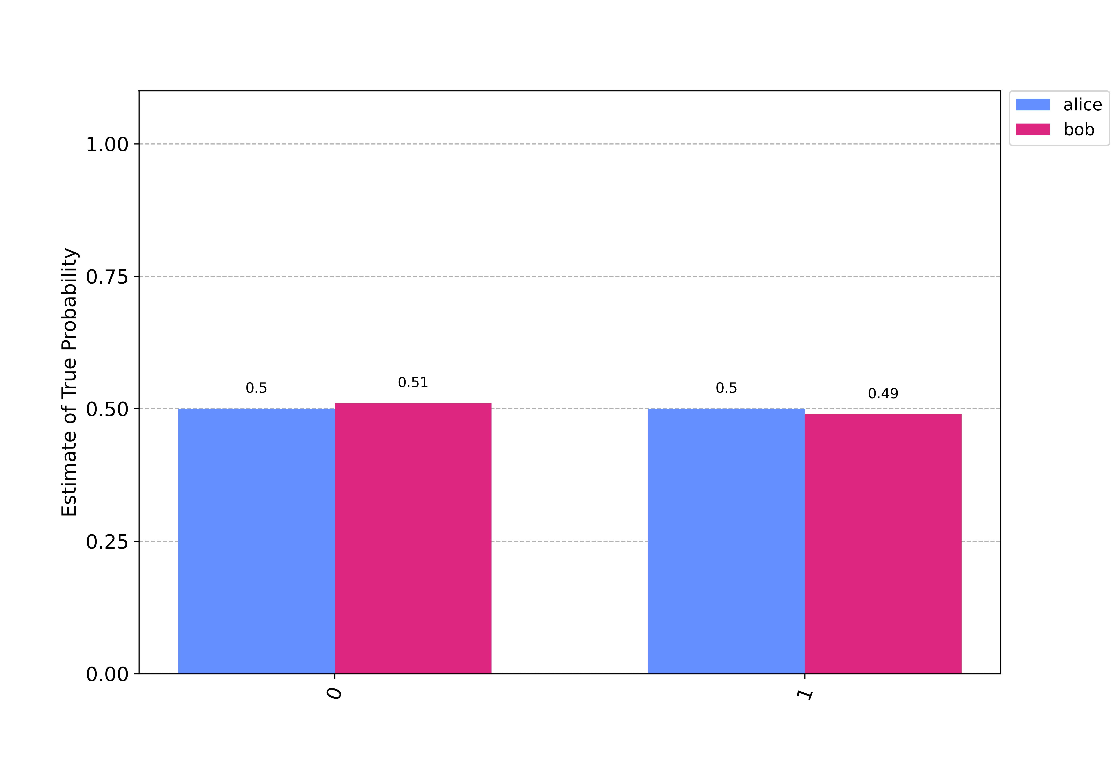  (b) Pre- and post- purification strategy
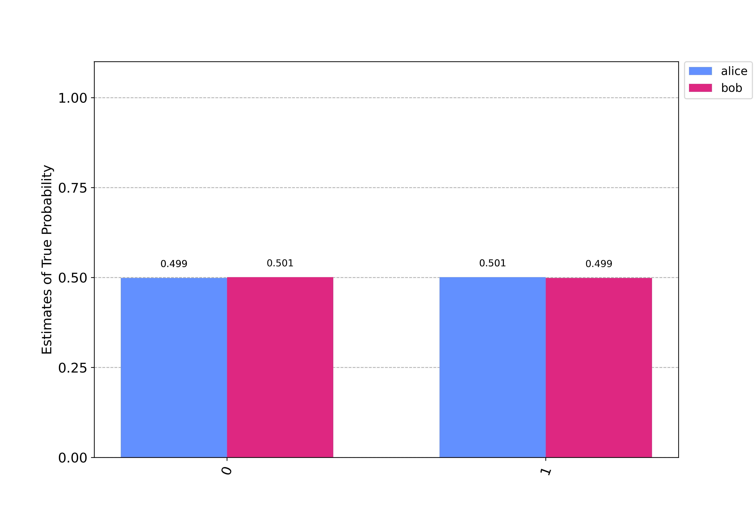
(c) Repeated post swap purification strategy

Figure 7: Results verifying the success of the teleportation of entanglement in the quantum repeater protocol between Alice and Bob under different strategies, as indicated in the graph.

Combining all collected data provides valuable insights into the optimal purification strategy that would be employed in practical quantum repeaters in the Noisy Intermediate-Scale Quantum (NISQ) era [27], in accordance with our formulation. All considered strategies consistently maintained a fidelity level above 50%, which is the minimum required to sustain a quantum communication link.
Multiple analyses underscored the robustness of the purification strategies for potential application in the quantum repeater protocol. Notably, the pre-and-post swap purification strategy emerged slightly favoured, consistently achieving a higher mean fidelity value averaging at 0.8 across numerous simulation iterations.
Analysis of the correlation between fidelity values at different stages of the quantum repeater protocol revealed a notable positive correlation among the strategies. This is especially pronounced between the pre-and-post swap and repeated post-swap strategies. This implies that the positive impact of purification is sustained through subsequent stages.
To evaluate the consistency of each purification strategy, we analysed the fidelity value distribution. The pre-and-post swap purification strategy not only maintained a high average fidelity but also exhibited lower variability, indicating a more reliable performance compared with alternative strategies. This underscores the effectiveness of a purification approach that is executed before and after entanglement swapping.

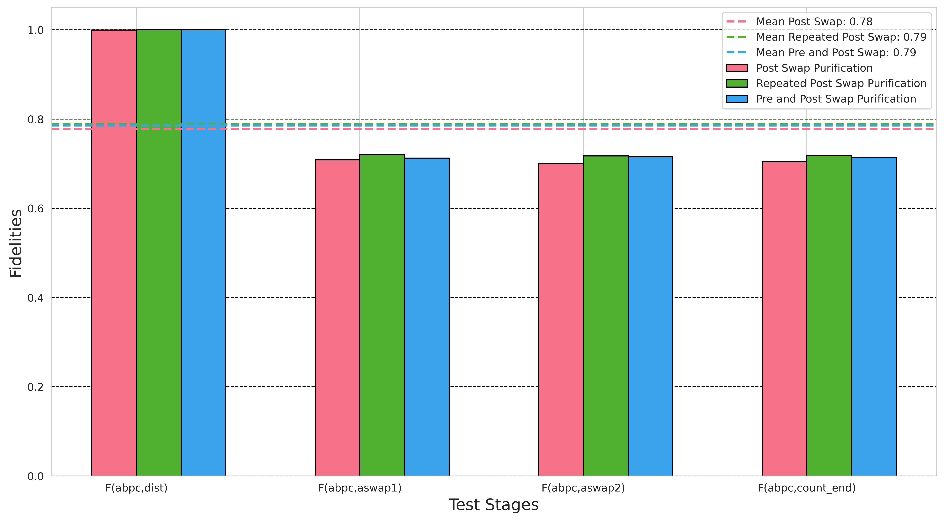
Figure 8: Effect of purification on fidelity across different purification strategies. The results were obtained from a circuit implementing an intermediate quantum repeater and hence two entanglement swapping procedures, labelled aswap1 and aswap2.

It is essential to acknowledge that, while there are minor differences in fidelity (see Fig. 8) and quantum repeater verification results (see Fig. 7), these differences hold limited statistical significance within the scope of our study. The main insight derived from this analysis is that we achieve nearly identical results from our purification protocols, regardless of the specific strategy employed. The pre-and-post swap strategy offers only a slight advantage, which can be attributed to its unique capability to purify both the incoming generated EPR pairs from a source and the post-entanglement swap pairs. This provides an efficient purification circuit design that strikingly balances initialization or loss errors (arising from imperfect raw Bell pairs) and operational errors arising from imperfect local operations [11]. Furthermore, compared with the repeated post-swap strategy, the pre-and-post swap strategy necessitates purification only once. Repeated purification fails to achieve any additional improvements and only increases circuit complexity, overhead, and the likelihood of contributing to additional errors due to imperfect local operations [11].
We obtain insights into the importance of selecting an appropriate purification strategy based on the employed protocol. We anticipate substantial differences arising when we consider a broader and diverse array of purification protocols and strategies beyond those explored in this study. Further investigations into the scalability and adaptability of these strategies are crucial for the continued development of quantum repeater systems.
3.3 Purification Optimization Scheme
The purification circuits underwent two levels of optimisation: a light and heavy optimisation scheme. The IBM Qiskit transpired is responsible for the optimisation levels. The purification optimisation scheme was carried out for all purification strategies tested earlier using the two major purification protocols, Bennett’s and Deutsch’s protocols.
For each of the three purification strategies, the circuit would first implement Deutsch’s purification protocol starting with light optimisation, and then the execution would be repeated using heavy optimisation followed by Bennett’s purification protocol with both the light and heavy optimisation schemes. Twenty independent measurement results were obtained from 20 iterations of the circuit runs per purification strategy. The probabilities were then averaged for each purification strategy to obtain an estimate of the true probability. These results were then used for each purification strategy to find the difference between Deutsch's and Bennett's estimate of probability under the light optimisation scheme and the heavy optimisation scheme before plotting them, as shown in Fig. 9. The differences are plotted as percentages.
The classical bits represent the classical states that can be measured by Alice and Bob at the end of the communication channel. The lower the percentage values, the less the distinction in the measurement outcomes between Deutsch’s and Bennett’s purification protocols when executed under the indicated optimisation scheme. The near zero percentage values imply convergence in the measurement results, suggesting a similarity in the efficacy of the purification protocols.

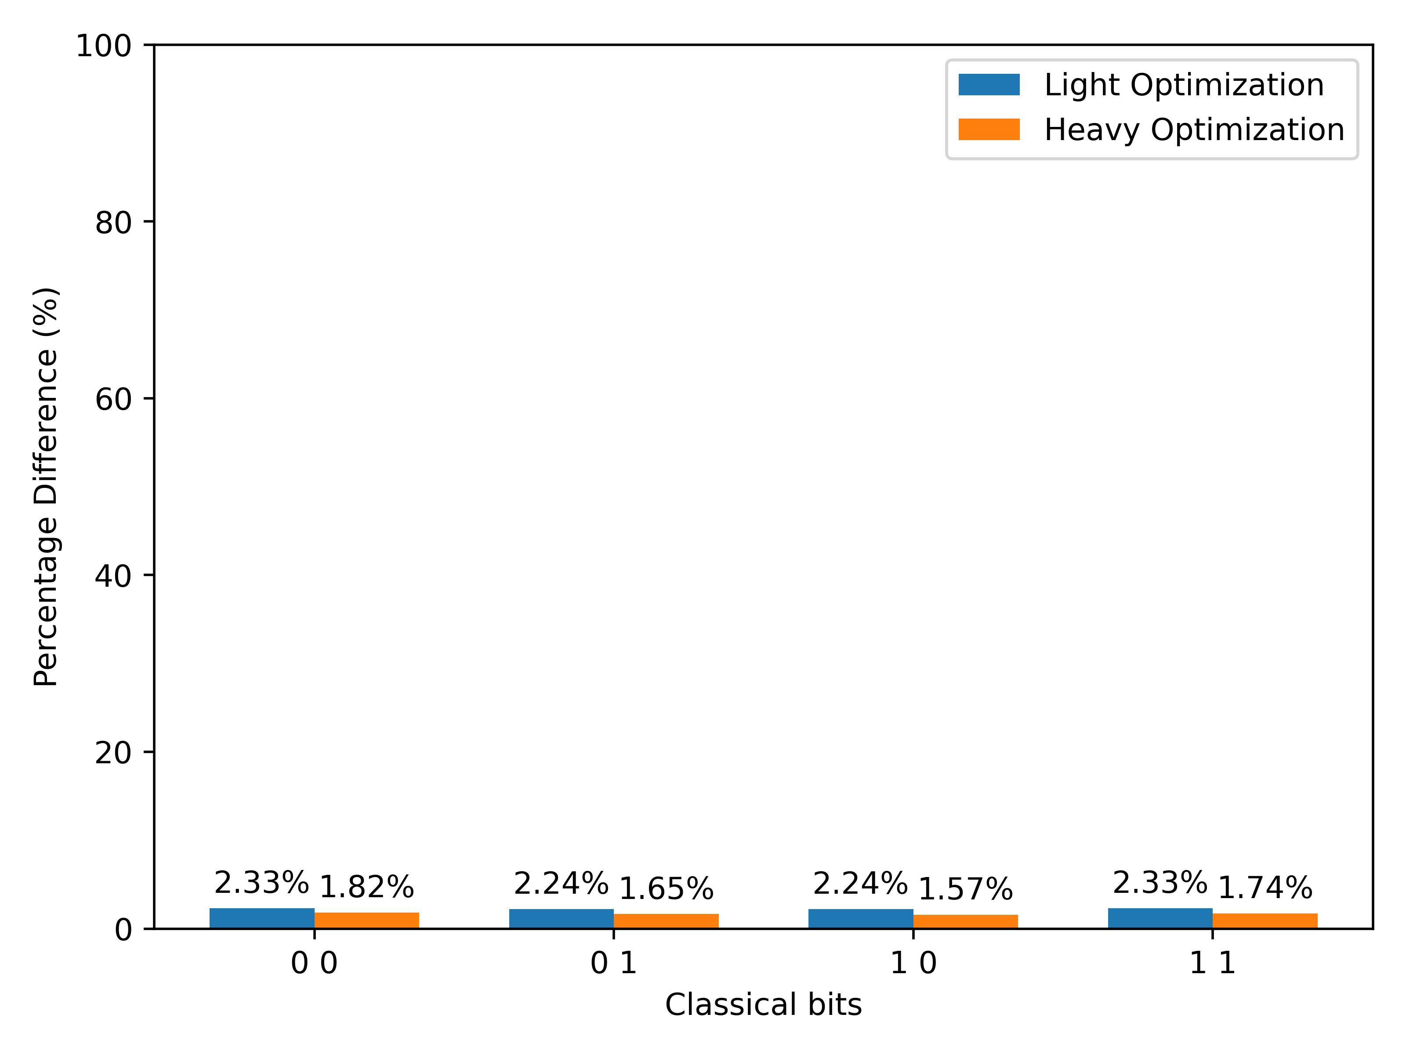  (a) Post swap | 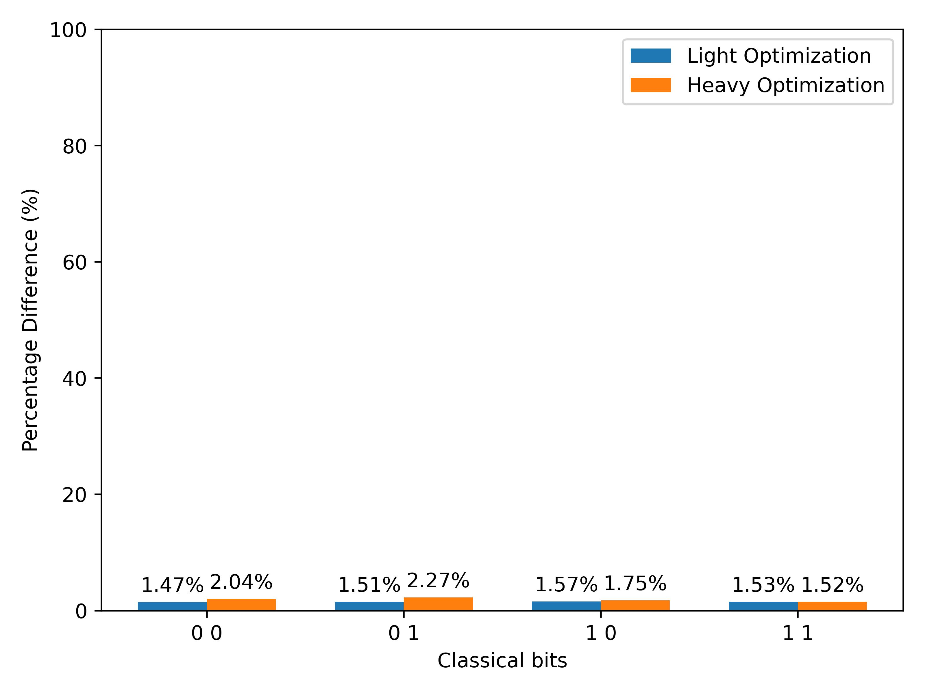  (b) Pre-and-post swap
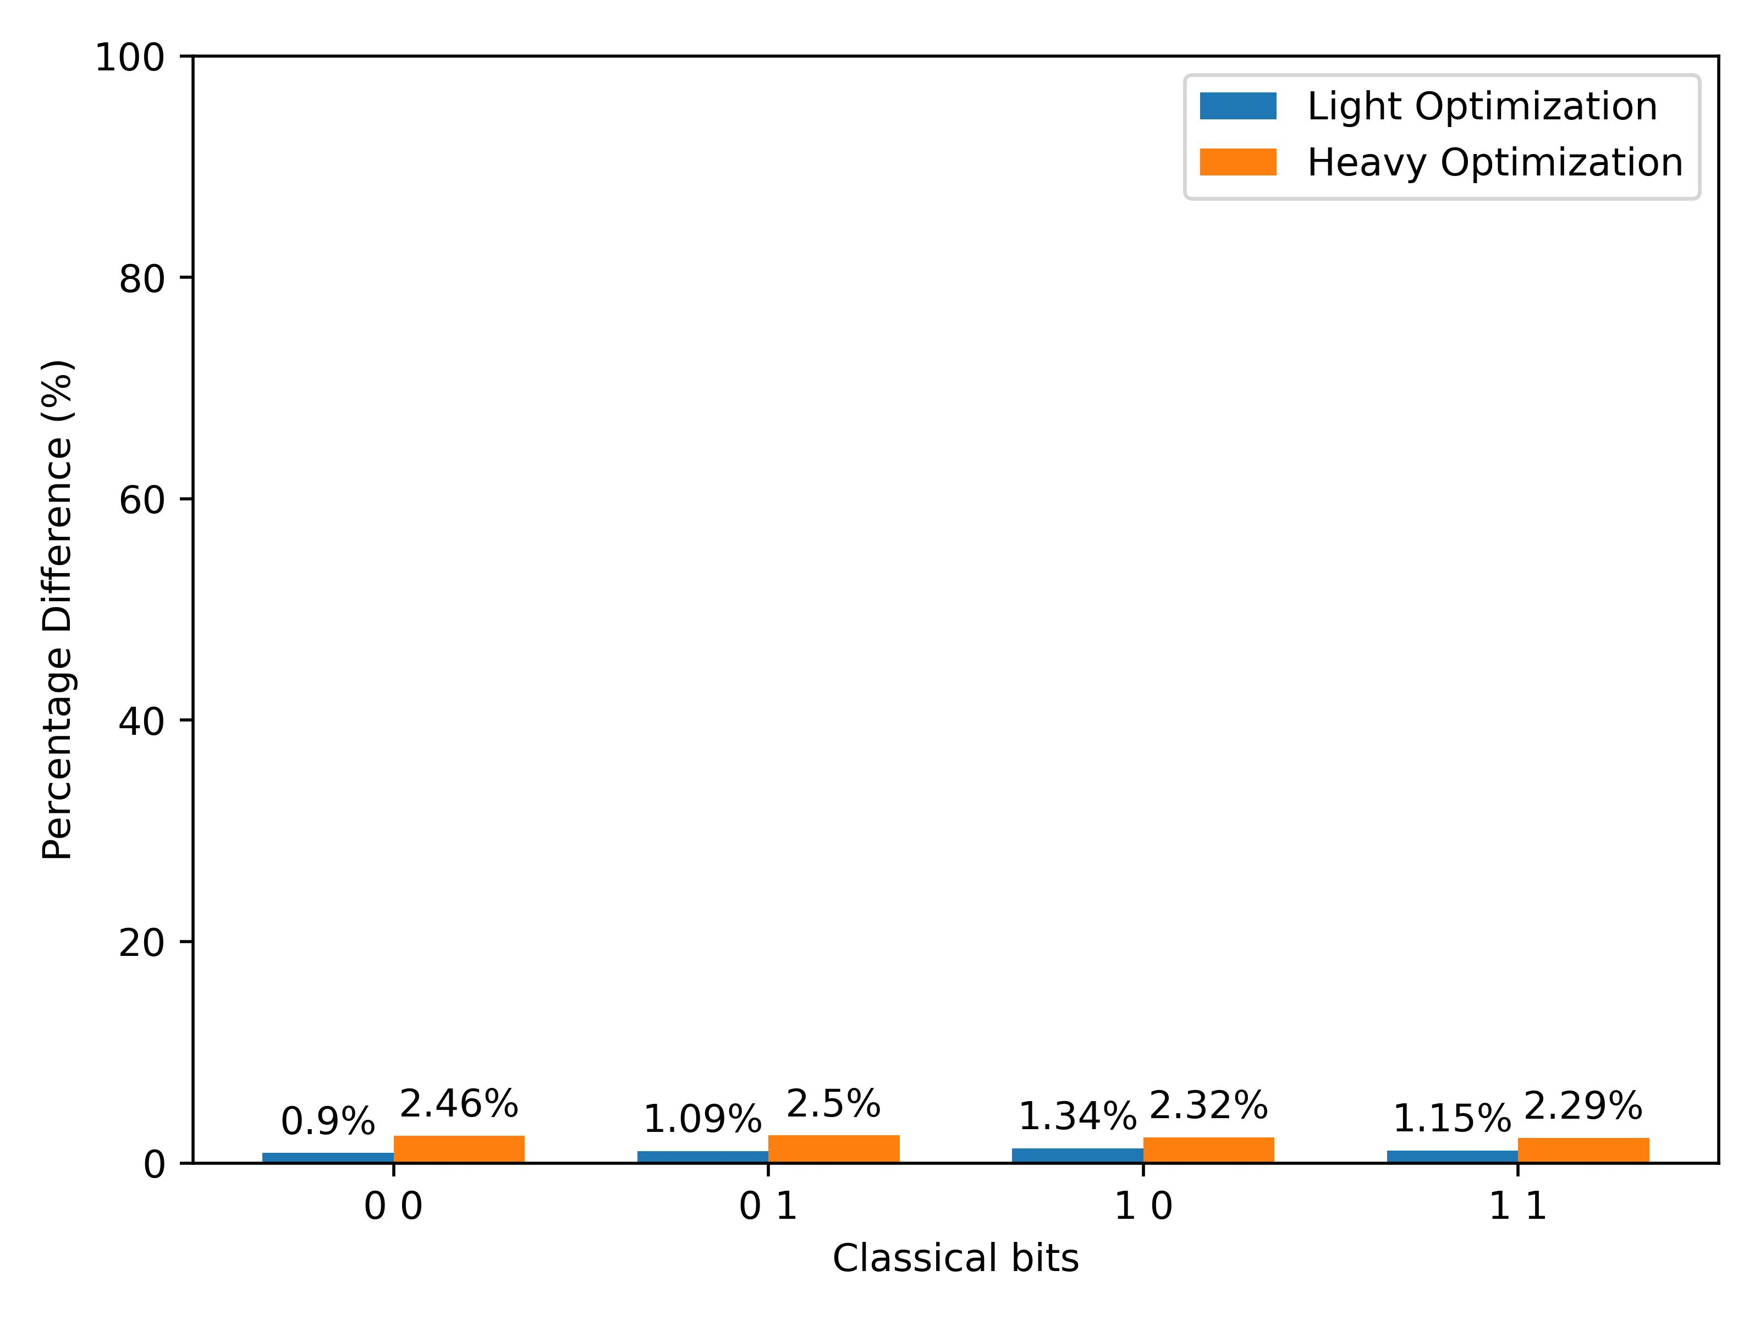
c) Repeated post swap

Figure 9: Results of experiments testing the differences in various purification protocols under different optimisation schemes. The experiments were conducted using different purification strategies.
The results from this experiment demonstrate and provide compelling proof to confirm that despite the differences in experimental requirements and efficiencies, the choice of purification protocols used in this study has no significant impact on the overall purification optimisation scheme employed in the purification circuits [8]. Further research can investigate the incorporation of more purification optimisation schemes, such as the discrete optimisation algorithms approach, that can generate efficient purification circuits that outperform many other general-purpose purification protocols [11].
4 Conclusions
This study presented a quantum repeater design setup and its implementation, providing valuable insight into entanglement purification. We have demonstrated various entanglement purification strategies and their subsequent circuit optimizations using the presented architecture. This research focussed on investigating entanglement purification strategies and the impact of optimisation schemes applied under two purification protocols in the context of near-term quantum repeaters [8].
Three distinct purification strategies were tested using the Deutsch purification protocol. The results consistently highlight the pre-and-post swap strategy as the most favourable approach in the scope of our studies, owing to its consistent high performance. Nonetheless, all strategies demonstrated robustness and efficiency in preserving entanglement and optimising quantum communication.
Notably, the purification protocols yielded similar results across the various strategies employed in our study. Furthermore, the different optimization levels had minimal impact on the performance of the purification strategies. Although the overall impact may be modest, specific purification strategies can introduce variations in the optimisation outcomes. The optimisation schemes did not favour any of the purification protocols employed.
This research underscores the significance of thoughtfully combining purification strategies and optimisation approaches to achieve significant improvements in quantum repeater performance, ultimately enhancing the efficiency of future practical quantum repeaters. We anticipate continued research efforts aimed at enhancing the success rate of entanglement swapping. Operational and loss errors remain persistent challenges in near-term quantum repeaters. It is evident that operational and loss errors persist as challenges in near-term quantum repeaters. Therefore, ongoing efforts should be directed towards the continual improvement and refinement of purification protocols and strategies. Through these endeavours, the realisation of a practical quantum repeater operating in the NISQ era has become an increasingly promising prospect.
Funding Statement: The authors acknowledge support from the University of Nairobi for this research.
Author Contributions: The authors affirm their comprehensive contributions to this paper, encompassing theoretical conception and design, data collection, analysis and interpretation, and drafting of the manuscript. All authors reviewed the results and subsequently approved the final version of the manuscript.
Availability of Data and Materials: All data used together with the code written for this research necessary to reproduce our results are available on GitHub [28].
Conflicts of Interest: The authors declare that they have no conflicts of interest to report regarding this study.

References
- C. H. Bennett, G. Brassard, C. Crépeau, R. Jozsa, A. Peres, and W. K. Wootters, “Teleporting an unknown quantum state via dual classical and Einstein-Podolsky-Rosen channels,” Phys. Rev. Lett., vol. 70, no. 13, pp. 1895-1899, Mar. 1993.
- Q. Ruihong and M. Ying, "Research Progress of Quantum Repeaters," Journal of Physics: Conference Series, vol. 1237, no. 5, Jun. 2019.
- L.-M. Duan, M. D. Lukin, J. I. Cirac, and P. Zoller, "Long-distance quantum communication with atomic ensembles and linear optics," Nature, vol. 414, no. 6862, pp. 413–418, Nov. 2001.
- H.-J. Briegel, W. Dür, J. I. Cirac, and P. Zoller, "Quantum Repeaters: The Role of Imperfect Local Operations in Quantum Communication," Phys. Rev. Lett., vol. 81, no. 26, pp. 5932-5935, Dec. 1998.
- S. Das, Md. S. Rahman, and M. Majumdar, "Design of a quantum repeater using quantum circuits and benchmarking its performance on an IBM quantum computer," Quantum Information Processing, vol. 20, no. 7, pp. 245, 2021.
- N. Gisin and R. Thew, "Quantum communication," Nature Photonics, vol. 1, no. 3, pp. 165-171, 2007.
- T. Herbst, T. Scheidl, M. Fink, J. Handsteiner, B. Wittmann, R. Ursin, and A. Zeilinger, "Teleportation of entanglement over 143 km," Proceedings of the National Academy of Sciences, vol. 112, no. 46, pp. 14202–14205, Nov. 2, 2015.
- S. Muralidharan, L. Li, J. Kim, N. Lütkenhaus, M. D. Lukin, and L. Jiang, "Optimal architectures for long distance quantum communication," Scientific Reports, vol. 6, no. 1, p. 20463, Feb. 15, 2016.
- C. H. Bennett, G. Brassard, S. Popescu, B. Schumacher, J. A. Smolin, and W. K. Wootters, "Purification of Noisy Entanglement and Faithful Teleportation via Noisy Channels," Phys. Rev. Lett., vol. 76, no. 5, pp. 722-725, Jan. 1996.
- D. Deutsch, A. Ekert, R. Jozsa, C. Macchiavello, S. Popescu, and A. Sanpera, "Quantum Privacy Amplification and the Security of Quantum Cryptography over Noisy Channels," Phys. Rev. Lett., vol. 77, no. 13, pp. 2818-2821, Sep. 1996.
- S. Krastanov, V. V. Albert, and L. Jiang, "Optimized Entanglement Purification," Quantum, vol. 3, p. 123, Feb. 2019.
- J. Rabbie, K. Chakraborty, G. Avis, and S. Wehner, "Designing quantum networks using preexisting infrastructure," npj Quantum Information, vol. 8, no. 1, p. 5, Jan. 20, 2022.
- J.-G. Ren, P. Xu, H.-L. Yong, L. Zhang, S.-K. Liao, J. Yin, W.-Y. Liu, W.-Q. Cai, M. Yang, L. Li, K.-X. Yang, X. Han, Y.-Q. Yao, J. Li, H. Wu, S. Wan, L. Liu, D.-Q. Liu, Y.-W. Kuang, Z.-P. He, P. Shang, C. Guo, R. Zheng, K. Tian, Z.-C. Zhu, N.-L. Liu, C.-Y. Lu, R. Shu, Y.-A. Chen, C.-Z. Peng, J.-Y. Wang, and J.-W. Pan, "Ground-to-satellite quantum teleportation," Nature, vol. 549, no. 7670, pp. 70–73, Sep 2017.
- C.-T. Liao, S. Bahrani, F. F. da Silva, and E. Kashefi, "Benchmarking of quantum protocols," Scientific Reports, vol. 12, no. 1, p. 5298, Mar 2022.
- G. Brennen, E. Giacobino, and C. Simon, "Focus on Quantum Memory," New Journal of Physics, vol. 17, no. 5, p. 050201, May 2015.
- L. Childress, J. M. Taylor, A. S. Sørensen, and M. D. Lukin, "Fault-Tolerant Quantum Communication Based on Solid-State Photon Emitters," Phys. Rev. Lett., vol. 96, no. 7, p. 070504, Feb 2006.
- A. I. Lvovsky, B. C. Sanders, and W. Tittel, "Optical quantum memory," Nature Photonics, vol. 3, no. 12, pp. 706–714, December 2009.
- P.-J. Stas, Y. Q. Huan, B. Machielse, E. N. Knall, A. Suleymanzade, B. Pingault, M. Sutula, S. W. Ding, C. M. Knaut, D. R. Assumpcao, Y.-C. Wei, M. K. Bhaskar, R. Riedinger, D. D. Sukachev, H. Park, M. Lončar, D. S. Levonian, and M. D. Lukin, "Robust multi-qubit quantum network node with integrated error detection," Science, vol. 378, no. 6619, pp. 557-560, 2022.
- J. Ji, Y.-F. Wu, S. C. Wein, F. K. Asadi, R. Ghobadi, and C. Simon, "Proposal for room-temperature quantum repeaters with nitrogen-vacancy centers and optomechanics," Quantum, vol. 6, p. 669, Mar 2022.
- S. Pirandola, J. Eisert, C. Weedbrook, A. Furusawa, and S. L. Braunstein, "Advances in quantum teleportation," Nature Photonics, vol. 9, no. 10, pp. 641–652, Oct 2015.
- V. Bayrakci and F. Ozaydin, "Quantum Zeno repeaters," Scientific Reports, vol. 12, no. 1, p. 15302, Sep 12, 2022.
- W. Kozlowski, A. Dahlberg, and S. Wehner, "Designing a Quantum Network Protocol," in Proceedings of the 16th International Conference on Emerging Networking EXperiments and Technologies (CoNEXT '20), Barcelona, Spain, pp. 1–16, 2020.
- G.-Z. Song, F.-Z. Wu, M. Zhang, and G.-J. Yang, "Heralded quantum repeater based on the scattering of photons off single emitters using parametric down-conversion source," Scientific Reports, vol. 6, no. 1, p. 28744, Jun 28, 2016.
- X. Liu, J. Hu, Z.-F. Li, X. Li, P.-Y. Li, P.-J. Liang, Z.-Q. Zhou, C.-F. Li, and G.-C. Guo, "Heralded entanglement distribution between two absorptive quantum memories," Nature, vol. 594, no. 7861, pp. 41–45, Jun 2021.
- L.-K. Chen, H.-L. Yong, P. Xu, X.-C. Yao, T. Xiang, Z.-D. Li, C. Liu, H. Lu, N.-L. Liu, L. Li, T. Yang, C.-Z. Peng, B. Zhao, Y.-A. Chen, and J.-W. Pan, "Experimental nested purification for a linear optical quantum repeater," Nature Photonics, vol. 11, no. 11, pp. 695–699, Nov 2017.
- L. Zhou, S.-S. Zhang, W. Zhong, and Y.-B. Sheng, "Multi-copy nested entanglement purification for quantum repeaters," Annals of Physics, vol. 412, p. 168042, 2020.
- J. Preskill, "Quantum Computing in the NISQ era and beyond," Quantum, vol. 2, p. 79, Aug 2018.
- A. K. Mũgambi, "Quantum Repeater Design," GitHub repository, 2023. [Online]. Available: https://github.com/Phystro/Quantum-Repeater-Design



REVISION SUMMARY
File name: Design and Implementation of Quantum Repeaters_revised.docx
(Run on 02 Nov 2023, 12:43:51 AM GMT)

Trinka scanned and edited your text for language errors and identified the areas of improvement. Here are the details.

This file had 5350 words and 274 revisions. Our initial assessment showed 36% as the language score for your uploaded file. The distribution of errors and improvements is shown below. A total of 3 suggestions have been added as comments in the document.

Category | Revisions
Abbreviations | 0
Adjectives/Adverbs | 6
Articles | 34
Capitalization & Spacing | 5
Conjunctions | 0
Difficult-to-read Sentence | 0
Enhancement | 0
Fragment | 0
Idioms | 0
Number Style | 0
Plain Language | 0
Prepositions | 13
Pronouns & Determiners | 0
Punctuation | 46
Redundancy & Conciseness | 0
Run-on Sentence | 0
Sensitive Language | 0
Singular-Plural nouns | 3
Spelling & Typos | 0
Style | 0
Subject-Verb Agreement | 3
Symbols/Notations | 0
Syntax | 2
Tense | 7
Verbs | 13
Word Form | 1
Word Order | 1
Word/Phrase Choice | 14
Writing Advisor | 0
Other | 126
Style Guide - None | 0
Total | 274

